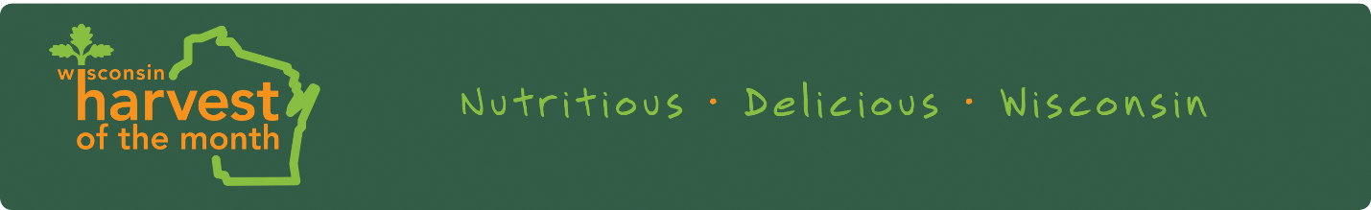
Greetings,

Our school is participating in Wisconsin Harvest of the Month! Harvest of the Month is a statewide campaign that encourages students to eat more fruits and vegetables. Each month, our school will feature one Wisconsin-grown fruit or vegetable that is seasonally available. We will encourage students to taste, explore, and learn about the importance of eating fruits and vegetables in the classroom and cafeteria.

Watch the school menu, newsletter, Facebook page, and postcards sent home with students for more information about the Harvest of the Month fruits and vegetables. We will feature fruits and veggies from this list:
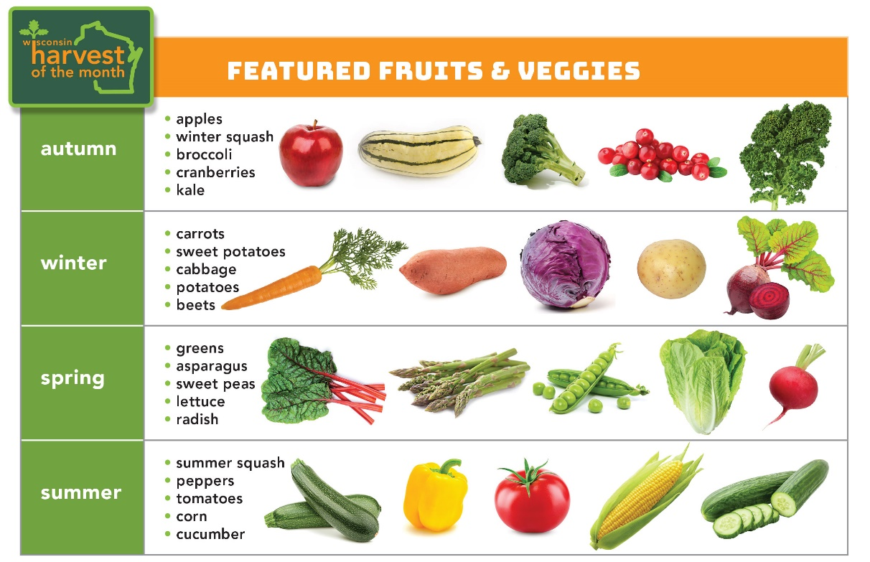

Ask your child about Harvest of the Month foods and prepare these foods at home. Providing many opportunities for your child to try new foods is important for building healthy eating habits and adventurous eaters.

We hope you join us in this opportunity to promote eating fruits and vegetables!

